The create_pandas_dataframe_agent is a built-in langchain agent. Which you can use to work with dataframes.
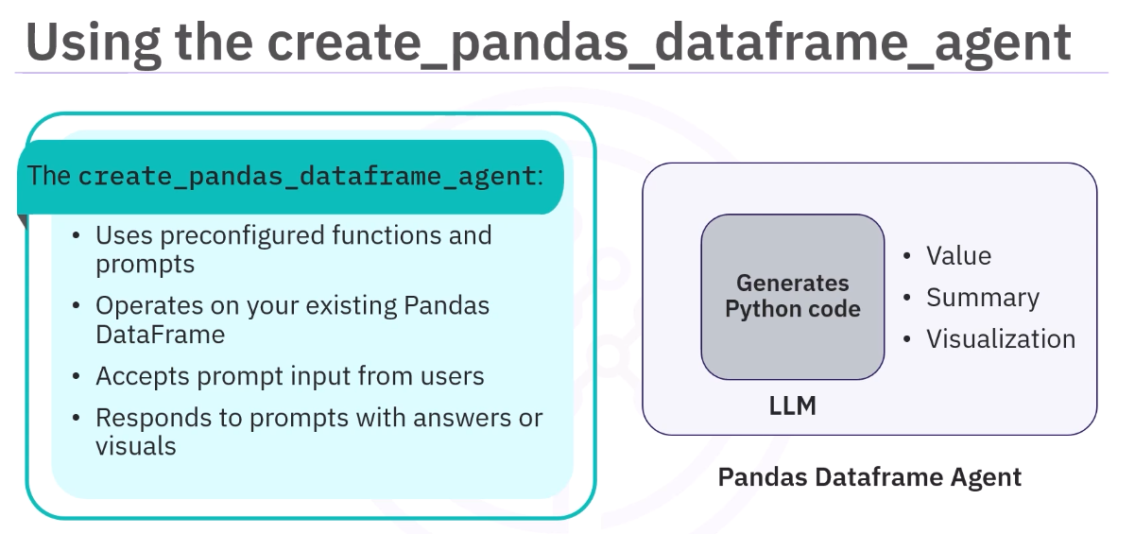
In order to have a dataframe you first import pandas library and then load the dataframe object…
Import pandas as pd
Df = pd.read_csv(path_to_csvfile)
After you have set up the model for use 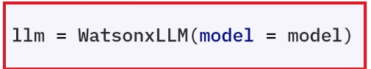. ​This action integrates watsonx LLM within LangChain to build chatbots, chains, and tools ​using LangChain's features.
Setting up the Pandas DataFrame agent:
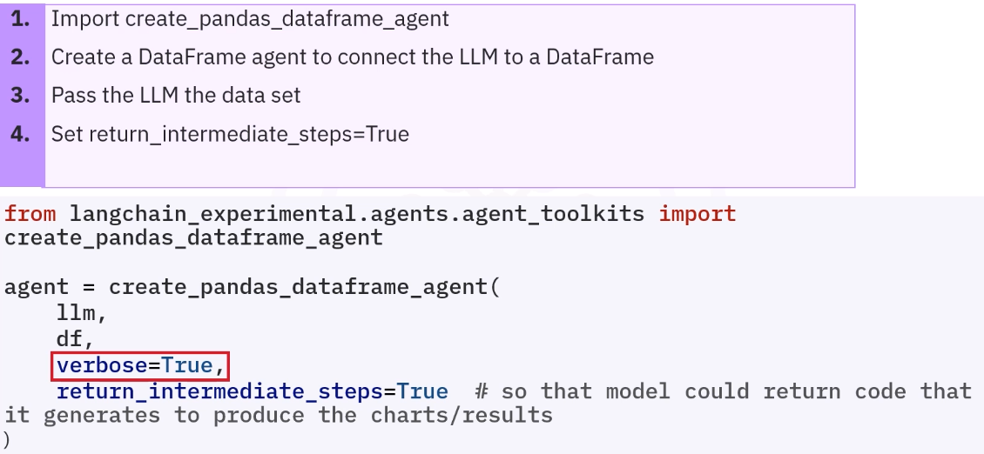
With this you have created an agent which is a built in agent offered by langchain. You pass on the llm, dataframe object in the parameter. You can invoke this agent and ask in natural language your query.

You can even, use natural language to generate visualizations like graphs.
